**Follow the Dockerfile & Image & Container etc.,**

1. Make Directory “docker” & check directory

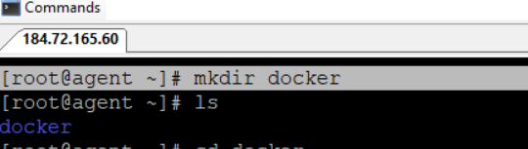

1. Create DockerFile

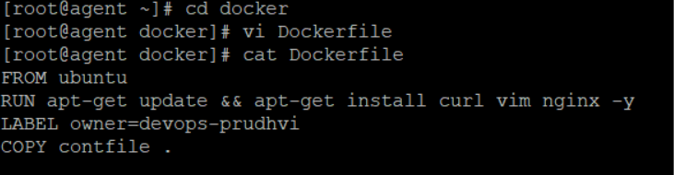

1. Create contfile into docker directory (or) get file from base maching

DockerFile => Check Copy Command file : contfile

**Error Message**

If contfile not exist, u will get below error message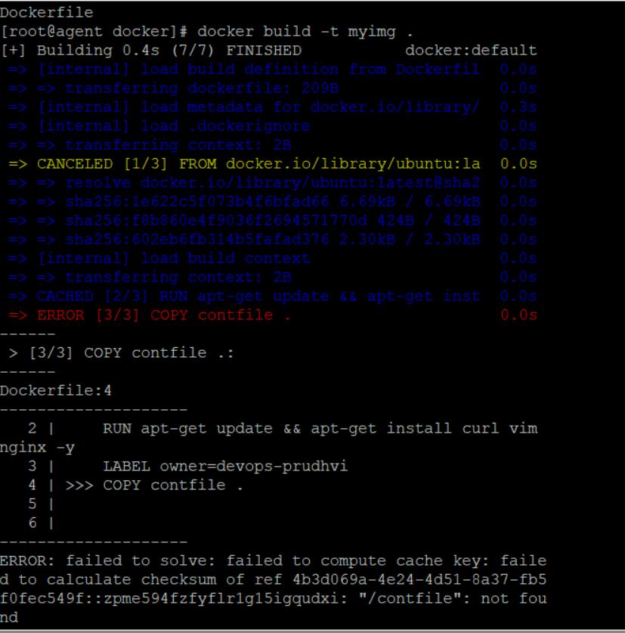

1. Create contfile into docker directory

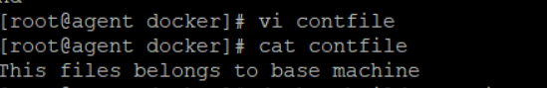

1. Next, build docker image using below command

docker build -t myimg .

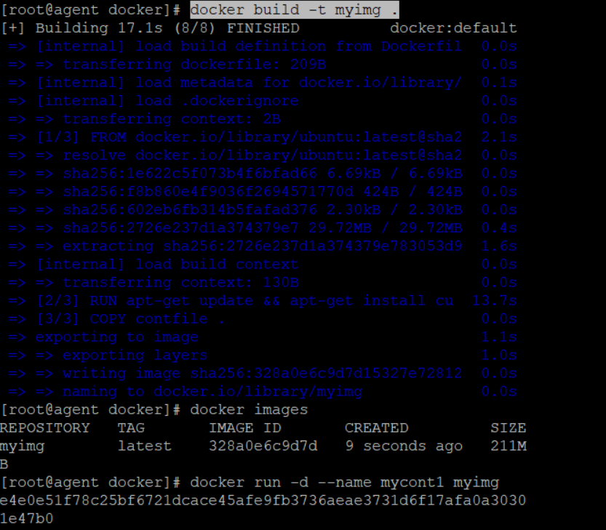

Successfully done – myimg repository

1. Create a container using image

[root@agent docker]# docker run -d --name mycont1 myimg

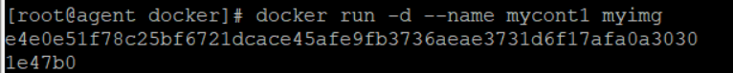

1. Go inside the container using below command

**Error message – Using exec**

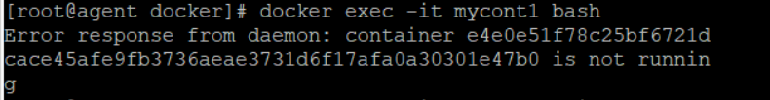

**Use RUN Command with different containername : mycont2**

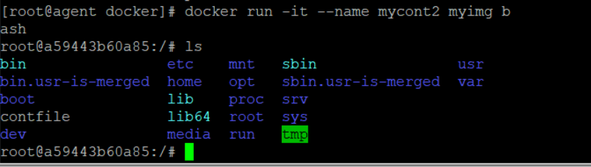

1. Tags are most important for developer perspection (or) rollout & rollback in production

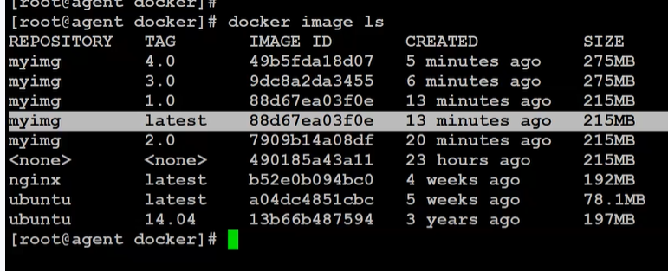

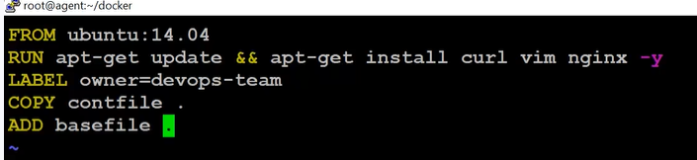

1. TAR File – collection multiple files

tar -cvzf project.tar partnercare-project

[: c =>create , v =>verbose(o/p display in terminal, z=> zipping, f=> filename]

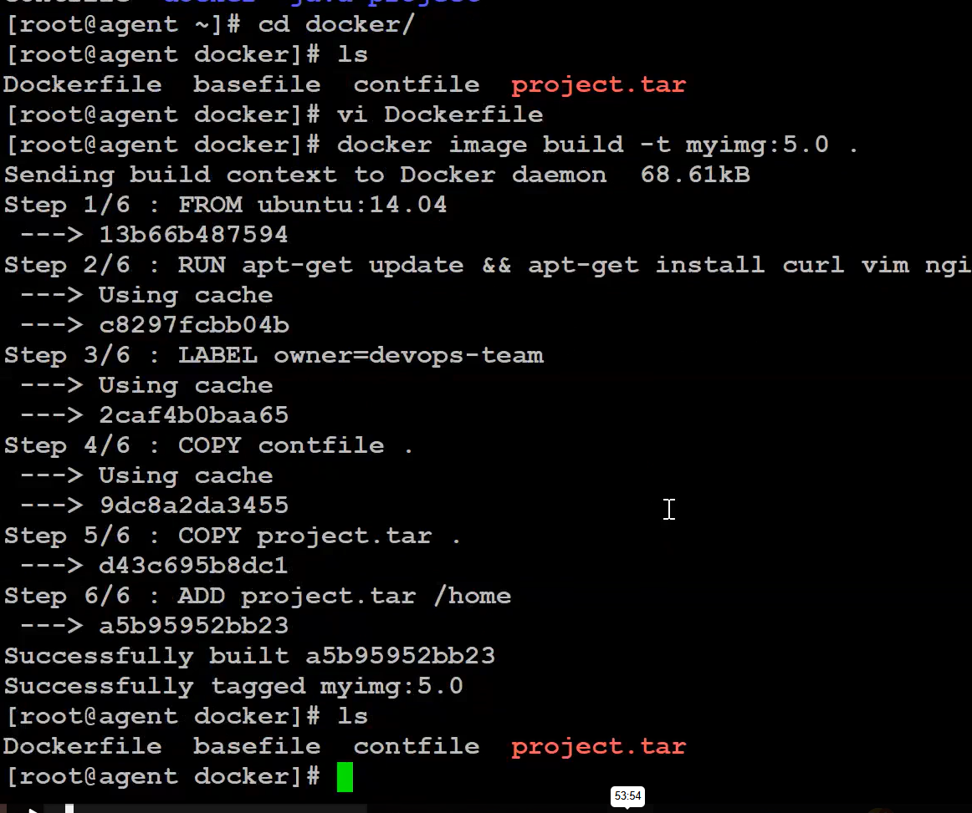

1. Create a container && run the containter

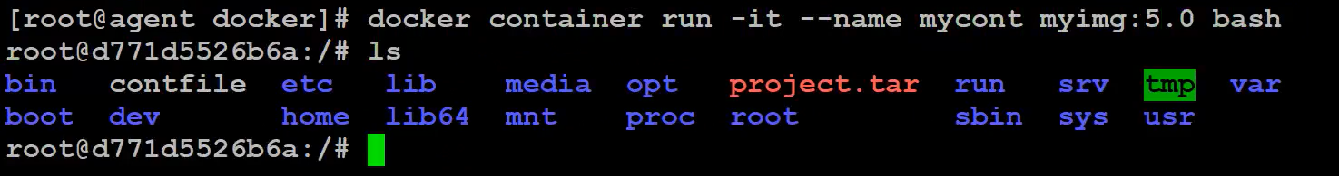

1. ADD Instruction in Dockerfile helps decompress the project without asking anything to client

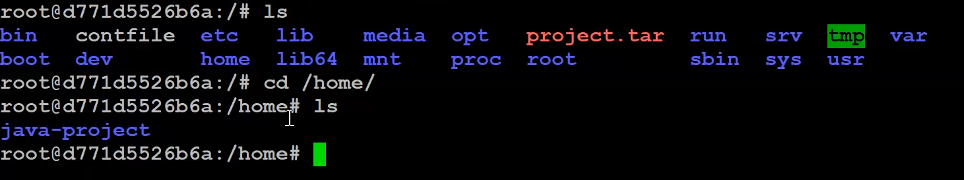Note : COPY instruction in Dockerfile file=> Copied it as it is like .tar no decompress tar file

1. Remove the container =>once image was done using singe command instead of “rm” command separate.

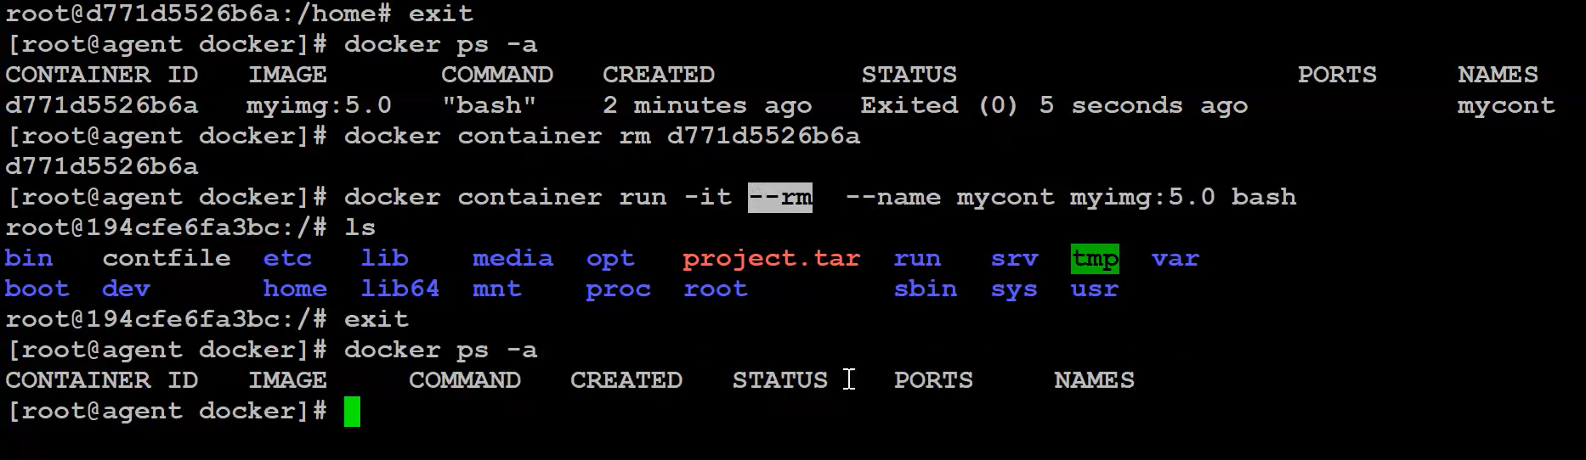

1. ENV Instruction usage in Docker file – consistent & Perfect solution using ENV value in File.

Permanent Env Variable

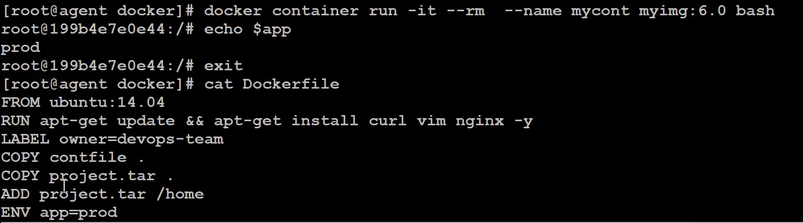

1. Testing/Troubleshoot ENV instruction using RUN Command – Temporary purpose



1. WORKDIR instruction usage land specific directory instead of root directory for user.

Build docker image

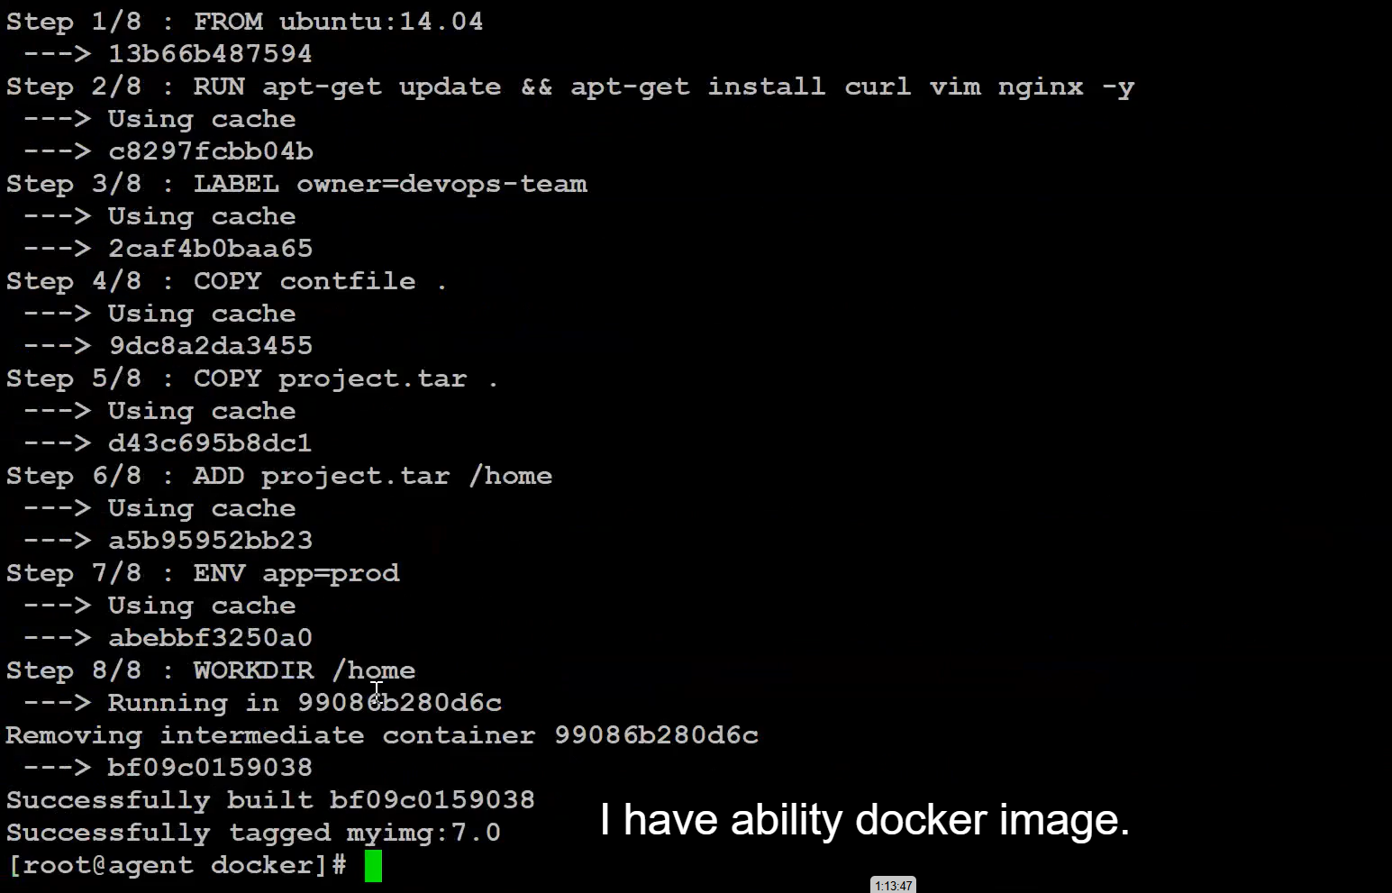

Build Container => land place home directory

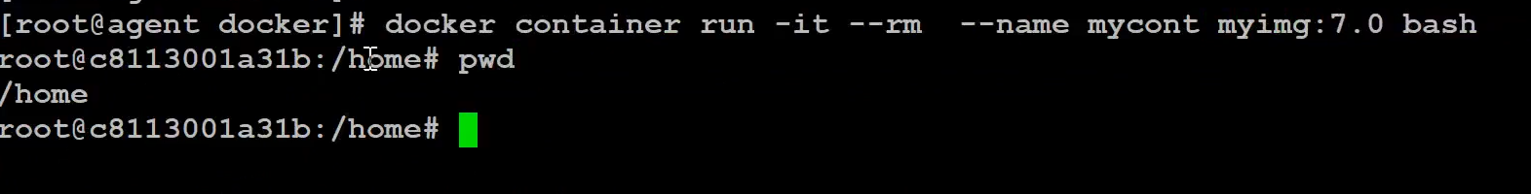

1. USER Instructions usage give access to specific user.

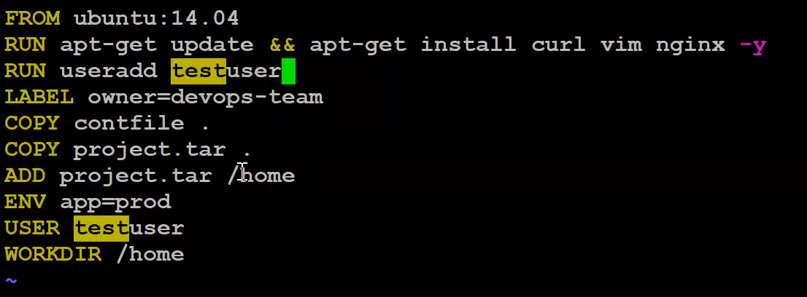

Build & run the container

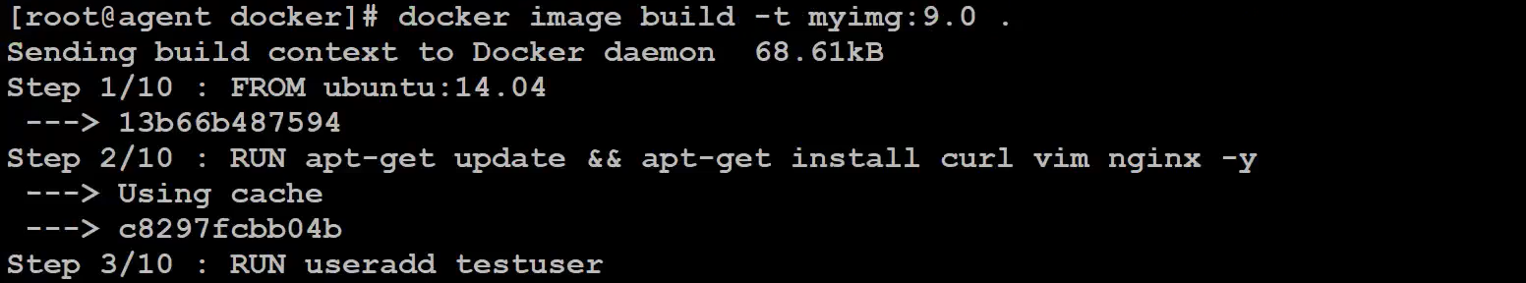

**Run the container – TAG should be same**



1. Docker Image History

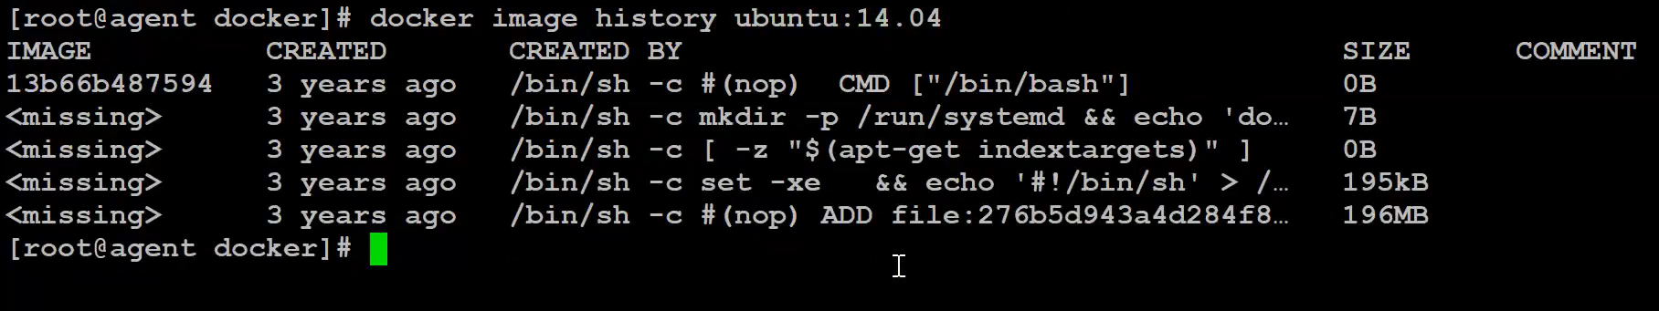

1. CMD Instruction is most important in Docker file. Without CMD instruction => No Docker file exists

DockerFile =>Simple Command

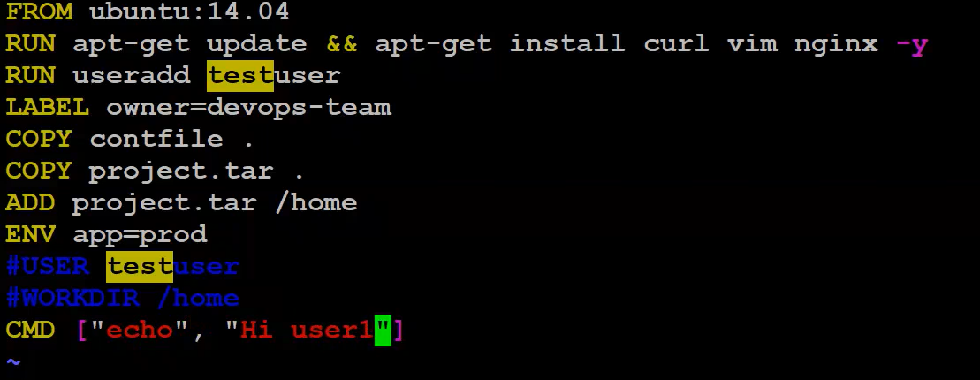

**NEXT => Build Docker Image**

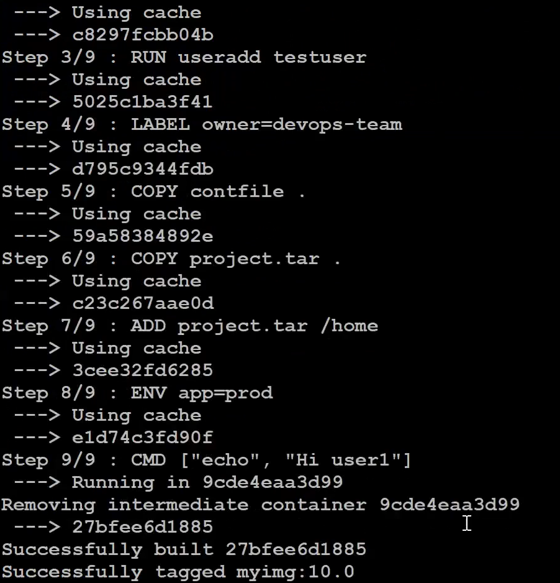

**Create a container => Display “Hi user1”**

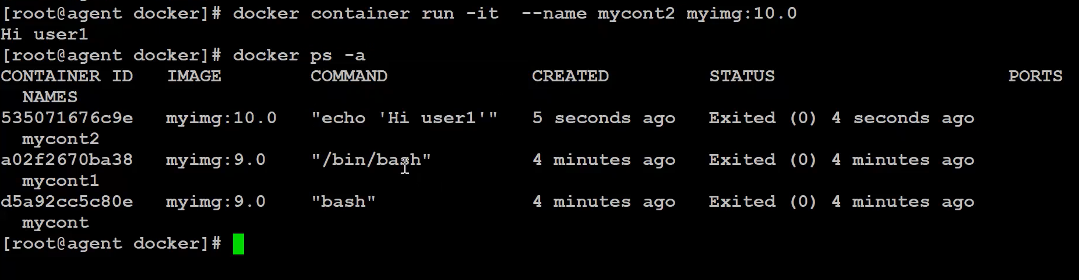

1. CMD instruction instead of echo => using shell script (useradd.sh) & added extra COPY Instruction useradd.sh filename

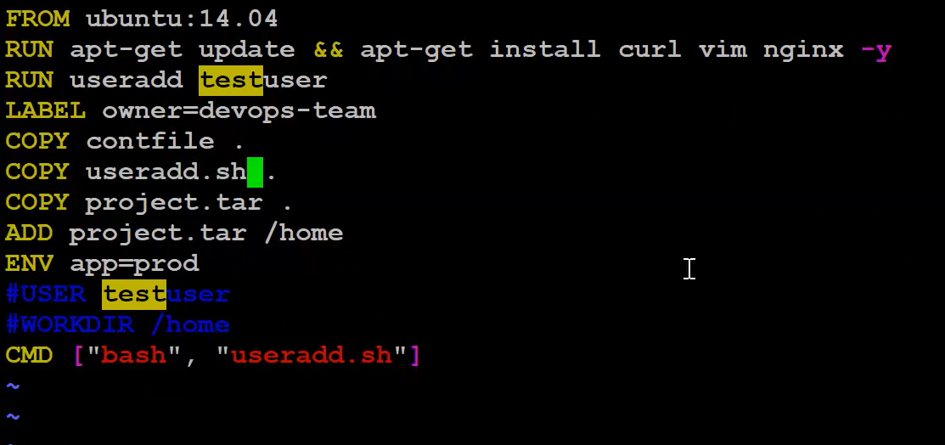

vi useradd.sh

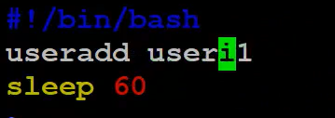

Build & run the container => sleep 60sec

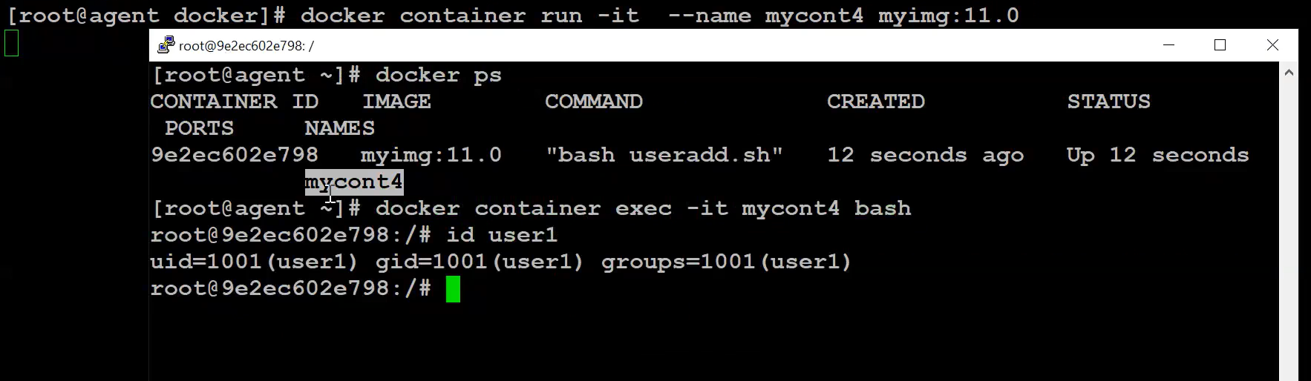

OUTPUT=> after 60 seconds => it comes out of container image to Base machine.

Note : Create user dynamic using $1 instead of useri1 => useradd.sh file

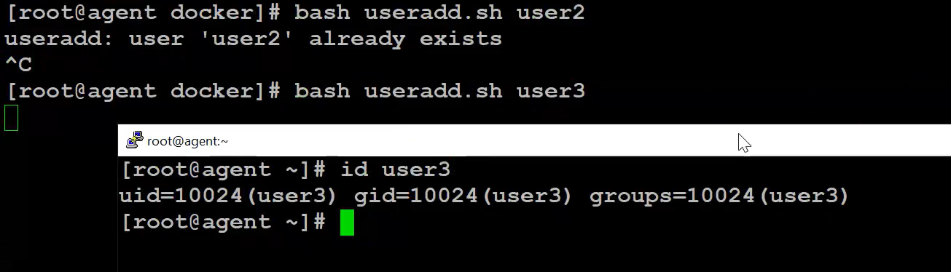

Other example of shell scripting

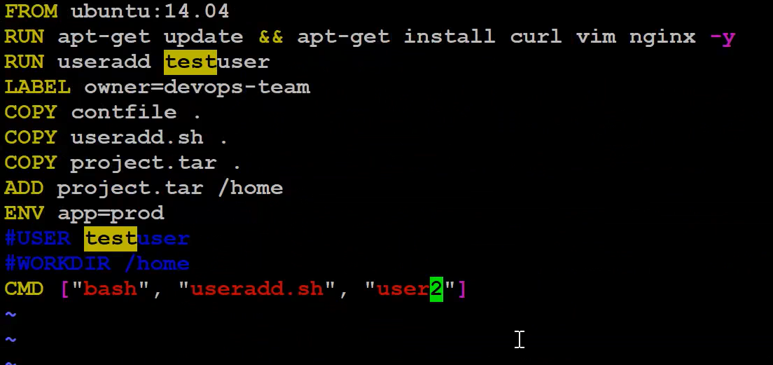

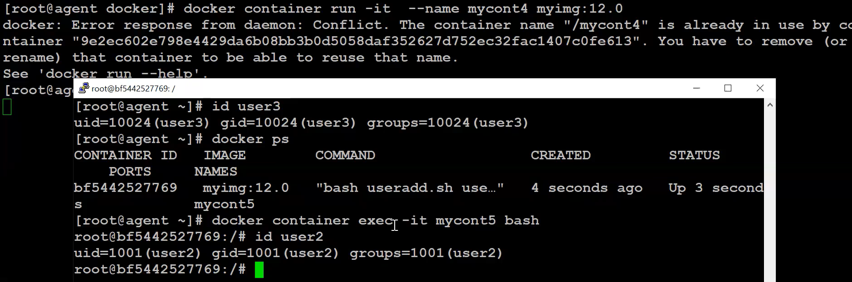

1. ENTRYPOINT instruction helps the dynamic support to append the runtime argument.

EntryPoint => just ‘hi’ Docker file but, in run container different names executing int runtime.

So, Entrypoint Instruction is very powerful to CMD instruction.

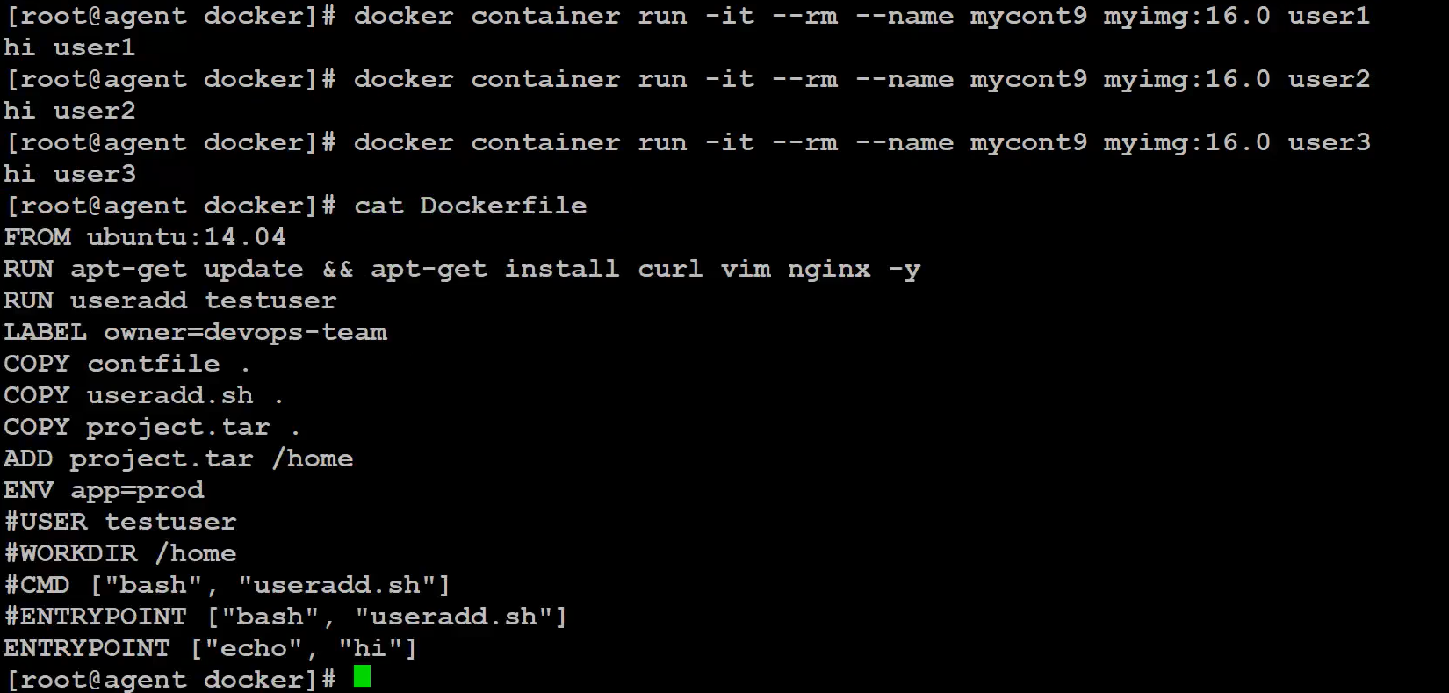



**Sample DockerFile**

